Maternal Coalition and Action Network (MOMsCAN)
Overview
The Jewish Healthcare Foundation (JHF) is working with partners to form the statewide Maternal Coalition and Action Network (MOMsCAN)—a Perinatal Quality Collaborative (PQC)—to lower maternal and infant mortality rates in Pennsylvania and achieve excellent attachment and outcomes for the mom and baby. The goal is to standup MOMsCAN in 2019 with partners across the Commonwealth. MOMsCAN will use research, training, quality improvement, technical assistance, and payment models to:
- Convene key stakeholders to establish a common vision, consensus on best practices, and a roadmap for how to move the current state to the ideal state
- Analyze common quality metrics across participating health systems to identify improvement opportunities
- Assist community agencies, healthcare organizations, and maternity care teams in adopting best practices for perinatal care
- Spread bundled perinatal payment models to support the adoption of best practices
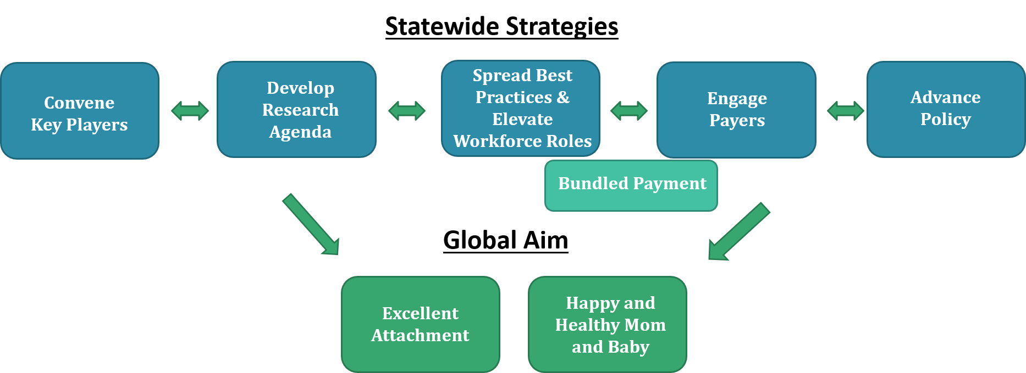

MOMsCAN Statewide Strategies
- Convene Key Players to Achieve a Common Vision and Strategy
MOMsCAN will build a multi-disciplinary coalition of maternity care teams, payers, and stakeholders across the Commonwealth to: 1) assess the regional gaps in care to identify quality targets, 2) identify best practices for improving the quality outcomes for the mom and baby, 3) develop a plan of action, and, 4) improve the ability of regions to act on improvements.
- Develop a Research Agenda to Disseminate Best Practices
To identify and respond to the gaps, MOMsCAN will analyze a common set of quality metrics. To accomplish this, MOMsCAN will: 1) conduct preliminary analyses to test metrics and identify high-need improvement domains, 2) create data specifications for perinatal quality metrics, and 3) provide stipends to high-volume OB/GYN health systems to enable them to analyze their data and submit the results to MOMsCAN. This effort is being supported by the Henry L. Hillman Foundation.
- Adopt Best Practices to Translate Research into Action
Once MOMsCAN identifies regional strengths and gaps in best practices and services, MOMsCAN will provide training and technical assistance to help the statewide coalition partners implement best practices for perinatal care. This will include a statewide effort to facilitate quarterly trainings, conduct Plan, Do, Study, Act (PDSA) quality improvement cycles in-between the trainings, spread best practices across the MOMsCAN coalition, and identify barriers and lessons learned.
- Spread Perinatal Bundled Payment Models
Bundled payment models tie a lump sum price and expected quality outcomes to a continuum of services for a health episode (such as a pregnancy). This enables providers to configure team roles and services across the perinatal continuum, with the goals of identifying and minimizing precursors that could cause harm during the prenatal period and achieving a successful dyad of the mom and baby during the postpartum period. MOMsCAN will help to identify and spread lessons learned for how to effectively design and implement perinatal bundled payment models.
- Advocate for Policies
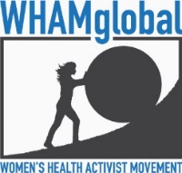
MOMsCAN will monitor policy barriers that may hinder the adoption of best practices, create policy recommendations, and advocate for change. This statewide effort will include developing a policy platform with talking points and issue briefs, coordinating advocacy efforts to advance the policy agenda, and monitoring and analyzing policy developments.

