WHAMglobal embraces the City’s “Welcoming Pittsburgh” Initiative:
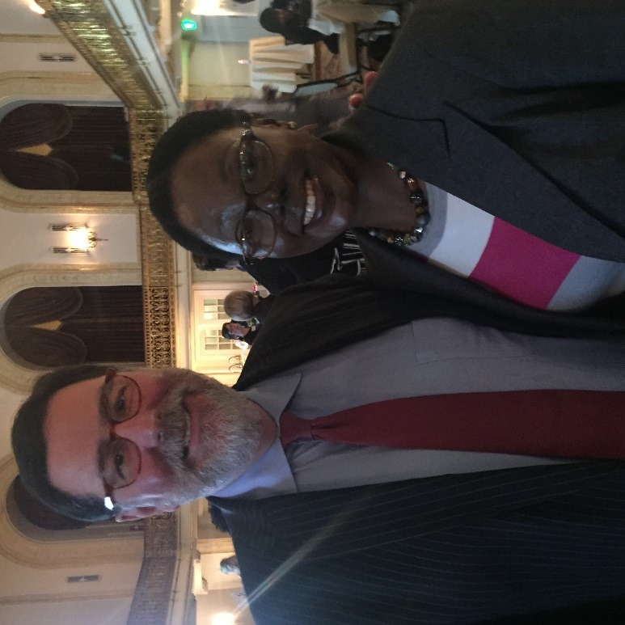
The welcoming Pittsburgh Initiative was launched by Major William Peduto in 2014 as a city’s commitment to ensure that Pittsburgh is a more livable city for all including internationals, Immigrants and Refugees. This year’s welcoming week kicked off with the second annual All for All summit on September 14, 2018 at the university club where WHAMglobal attended a day of learning and information sharing.
Moderated by Tiffany Chang Lawson from the office of the Pennsylvania governor, she challenged the audience with her powerful remark; “How do we build solidarity to make sure that immigrants regardless of status feel welcome in our region? It is not enough to say you support immigrants. You are losing out if you are not actively recruiting, actively including, and actively engaging immigrants. The questions becomes, how do we build a welcoming community?”
Dr. Karen Hacker, a WHAMglobal advisory board member presented a report by the Allegheny County Health Department about immigrant services in promoting nutrition health in our region. Dr. Hacker emphasized that as the health department, there is need to do a better job to communicate the multilevel process involved in accessing services and make the experience logical and easy for immigrants. One of WHAMglobal’s core commitment is to promote women’s health including immigrant and refugee communities by promoting not just cultural competence but also cultural humility in healthcare services that meet the needs of women in these communities.
Pittsburgh borrows best practices from the Ohio welcoming initiatives network (OWIN) in order to successfully build welcoming communities for immigrants in our region” Dan Gilman, chief of staff, city of Pittsburgh mayor’s office.
During this welcoming week, Hanifa Nakiryowa, our global health associate was one the lead presenters and a panelist during the Refugee and Immigrant Care Conference on September 17 2018 at the Allegheny Center Alliance Church (ACAC) where she shared the work of WHAMglobal in advancing maternal and child health among immigrant and refugee communities. Hosted by Geneva College and the Allegheny Center Alliance Church, the conference centered on the role of Faith Based Organizations in promoting a welcoming region for immigrants, refugees as well as non-immigrants (internationals).
The office of Mayor William Peduto, in his words, “works to ensure that as a welcoming city, we have to work with the people that are already here to make somebody want to stay”. When talking to Mayor Peduto, sharing the work of WHAMglobal and appreciating the city’s initiative to promote diversity and inclusion, he said “and we should not forget to add that welcoming immigrants is not just the right thing to do, but is necessary for the growth of our region, and immigrants bring the rich and diverse talent which enhances that growth”.

